[**Shop Bewakoof**](https://bewakoof.app.link/?%243p=blog_cta_&~campaign=cta_clicks&~channel=blog_banner&~feature=website_direct&$desktop_url=https://www.bewakoof.com/?&$fallback_url=https://www.bewakoof.com/?&$deeplink_path=www.bewakoof.com/?&utm_source=blog&utm_medium=blog&utm_campaign=cta_clicks&gclid=%7Bgclid%7D&~ad_set_id=%7Badgroupid%7D&~campaign_id=%7Bcampaignid%7D&~keyword=%7Bkeyword%7D&~placement=%7Bplacement%7D)

* [Fashion](https://www.bewakoof.com/blog/fashion/)
* [Beauty](https://www.bewakoof.com/blog/beauty/)
* [Entertainment](https://www.bewakoof.com/blog/entertainment/)
* [Leisure](https://www.bewakoof.com/blog/leisure/)
* [Fitness](https://www.bewakoof.com/blog/fitness/)
* [Shopping](https://www.bewakoof.com/blog/shopping/)
* [General](https://www.bewakoof.com/blog/general/)

[Home](https://www.bewakoof.com/blog) » [Fashion](https://www.bewakoof.com/blog/fashion/) » Dressing for Different Occasions

[Fashion](https://www.bewakoof.com/blog/fashion/)

**Dressing for Different Occasions: How to Dress for Weddings, Festivals, and More**

By [Bewakoof](https://www.bewakoof.com/blog/author/bewakoof/" \o "Posts by Bewakoof)Updated:May 28, 20249 Mins Read

[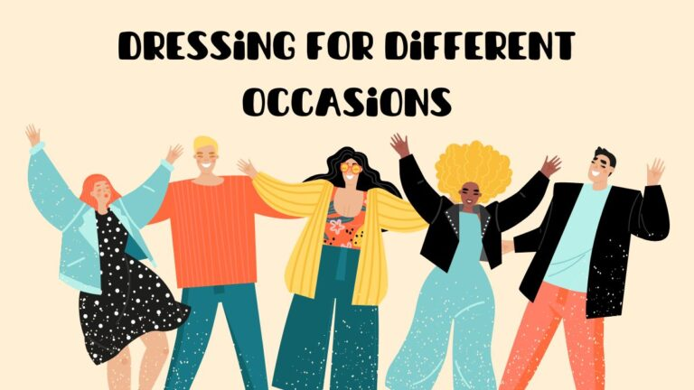](https://www.bewakoof.com/blog/wp-content/uploads/2023/04/Dressing-for-Different-Occasions.jpg)

1. x

x

[Top 10 Affordable Fashion Finds](https://www.humix.com/video/xi4X6p4c6y2)

Share

[Watch on](https://www.humix.com/video/xi4X6p4c6y2" \t "_blank)

[[](https://www.humix.com/video/xi4X6p4c6y2)](https://www.humix.com/video/xi4X6p4c6y2" \t "_blank)

[Top 10 Affordable Fashion Finds](https://www.humix.com/video/xi4X6p4c6y2)

**Share**

[**Save**](https://www.pinterest.com/pin/create/button/?guid=jTqRu_e9aA3J-1&url=https%3A%2F%2Fwww.bewakoof.com%2Fblog%2Fdressing-for-different-occasions%2F&media=https%3A%2F%2Fwww.bewakoof.com%2Fblog%2Fwp-content%2Fuploads%2F2023%2F04%2FDressing-for-Different-Occasions.jpg&description=Dressing%20for%20Different%20Occasions%3A%20How%20to%20Dress%20for%20Weddings%2C%20Festivals%2C%20and%20More)

As a multifaceted Indian fashion brand, we are thrilled to share with you some awesome ideas on how to dress for weddings, festivals, and more. In this blog, we will guide you through the various styles and trends that you can incorporate into your wardrobe for different occasions.

So, whether you’re a fashion enthusiast or someone looking to explore new styles, sit back, relax, and let’s delve into the world of Indian fashion together. Let’s get started!

Table of Contents

* [Exploring Different Types of Events & Appropriate Dress Code](https://www.bewakoof.com/blog/dressing-for-different-occasions/#Exploring_Different_Types_of_Events_Appropriate_Dress_Code)
* [How to Dress for Formal Occasions such as Weddings & Galas](https://www.bewakoof.com/blog/dressing-for-different-occasions/#How_to_Dress_for_Formal_Occasions_such_as_Weddings_Galas)
* [Be the Best-Dressed on Special Occasions like Anniversaries & Birthdays](https://www.bewakoof.com/blog/dressing-for-different-occasions/#Be_the_Best-Dressed_on_Special_Occasions_like_Anniversaries_Birthdays)
  + [Anniversary Outfits](https://www.bewakoof.com/blog/dressing-for-different-occasions/#Anniversary_Outfits)
  + [Birthday Outfits](https://www.bewakoof.com/blog/dressing-for-different-occasions/#Birthday_Outfits)
* [Tips to be the Best-Dressed](https://www.bewakoof.com/blog/dressing-for-different-occasions/#Tips_to_be_the_Best-Dressed)
* [Tips on Dressing for Fun-Filled Events like Festivals & Concerts](https://www.bewakoof.com/blog/dressing-for-different-occasions/#Tips_on_Dressing_for_Fun-Filled_Events_like_Festivals_Concerts)
* [What are the Best Outfit Ideas for Semi-Formal Events?](https://www.bewakoof.com/blog/dressing-for-different-occasions/#What_are_the_Best_Outfit_Ideas_for_Semi-Formal_Events)

**Exploring Different Types of Events & Appropriate Dress Code**

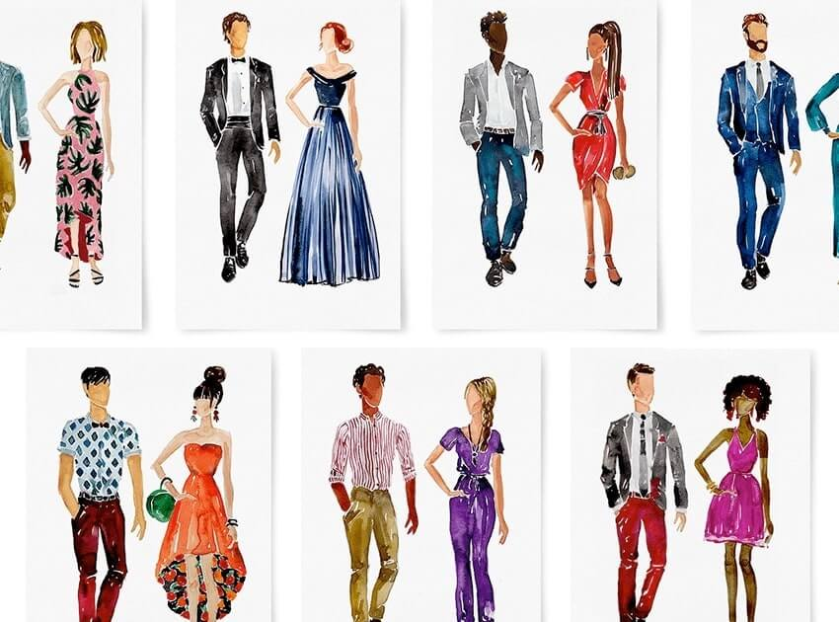Source – Greenvelope

[India](https://en.wikipedia.org/wiki/India) is a land of diverse traditions and cultures. Our fashion is a true reflection of this diversity. Whether it’s a grand wedding, a traditional festival, or a casual gathering, **dressing for different occasions** appropriately is an essential part of our customs.

We believe that dressing for different occasions appropriately is essential. It not only showcases your fashion sense but also reflects your respect for the occasion and its cultural significance. Here are some of the different types of events and the appropriate dress codes for each of them:

* **Weddings**: Weddings in India are grand affairs, and dressing up for them is no exception. For women, a heavy silk or embroidered saree or a lehenga choli is the go-to choice. Men can opt for a classic sherwani, a fine bandhgala suit, or an elegant kurta pajama.

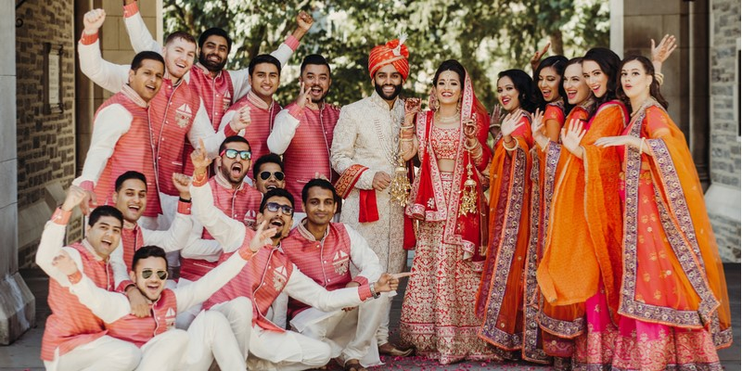Source – Shilpa Ahuja

* **Festivals**: Festivals in India are celebrated with great enthusiasm, so having a good **dressing style** for them is a must. For women, a stunning salwar kameez or a kurta with leggings or palazzo pants is a good choice. Men can opt for a chic kurta pajama or a traditional dhoti kurta, which are both conventional and stylish.

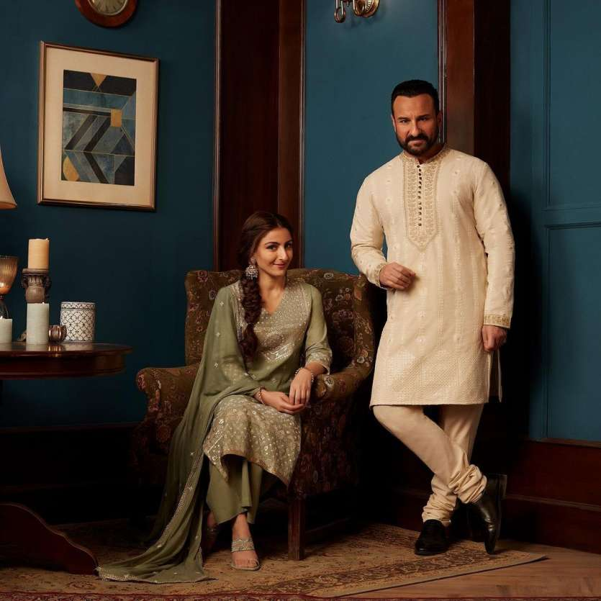Source – India Tv News

* **Formal events**: Formal events such as award ceremonies, galas, and black-tie events have a dress code. For women, an elegant gown or a cocktail dress is an appropriate choice. Men can opt for a sharp formal suit, an edgy tuxedo, or a regal bandhgala suit.

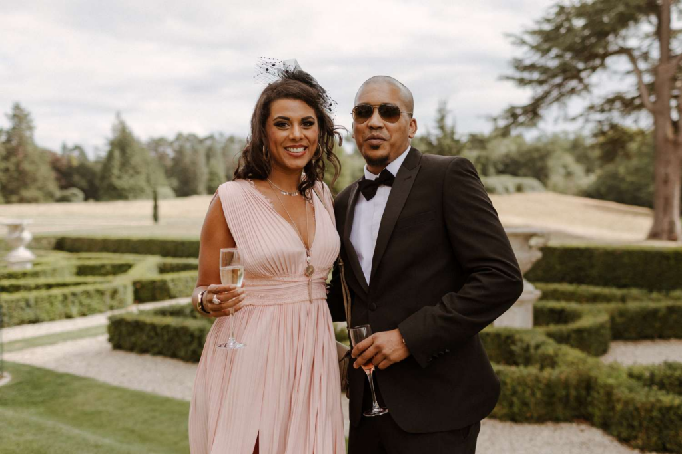Source – Brides

* **Casual events**: Casual events such as brunches, lunches, and day outings require a more relaxed dress code. For women, a flowy maxi dress or a happening jumpsuit is a good choice. You can even opt for [**tops for women**](https://bewakoof.app.link/?%243p=blog_text_clicks&~campaign=text_clicks&~channel=blog_text_clicks&~feature=collection_page&$desktop_url=https://www.bewakoof.com/fashion-tops?&$fallback_url=https://www.bewakoof.com/fashion-tops?&$deeplink_path=www.bewakoof.com/fashion-tops?&utm_source=blog_text_clicks&utm_medium=blog_text_click&utm_campaign=text_clicks&gclid=%7Bgclid%7D&~ad_set_id=%7Badgroupid%7D&~campaign_id=%7Bcampaignid%7D&~keyword=%7Bkeyword%7D&~placement=%7Bplacement%7D) or [**shirts for women**](https://bewakoof.app.link/?%243p=blog_text_clicks&~campaign=text_clicks&~channel=blog_text_clicks&~feature=collection_page&$desktop_url=https://www.bewakoof.com/women-shirts?&$fallback_url=https://www.bewakoof.com/women-shirts?&$deeplink_path=www.bewakoof.com/women-shirts?&utm_source=blog_text_clicks&utm_medium=blog_text_click&utm_campaign=text_clicks&gclid=%7Bgclid%7D&~ad_set_id=%7Badgroupid%7D&~campaign_id=%7Bcampaignid%7D&~keyword=%7Bkeyword%7D&~placement=%7Bplacement%7D)**,** and a pair of [**jeans for women**](https://bewakoof.app.link/?%243p=blog_text_clicks&~campaign=text_clicks&~channel=blog_text_clicks&~feature=collection_page&$desktop_url=https://www.bewakoof.com/womens-denims?&$fallback_url=https://www.bewakoof.com/womens-denims?&$deeplink_path=www.bewakoof.com/womens-denims?&utm_source=blog_text_clicks&utm_medium=blog_text_click&utm_campaign=text_clicks&gclid=%7Bgclid%7D&~ad_set_id=%7Badgroupid%7D&~campaign_id=%7Bcampaignid%7D&~keyword=%7Bkeyword%7D&~placement=%7Bplacement%7D). Men can opt for a well-fitted shirt and jeans for men or chinos or a casual kurta with[**jeans for men**](https://bewakoof.app.link/?%243p=blog_text_clicks&~campaign=text_clicks&~channel=blog_text_clicks&~feature=collection_page&$desktop_url=https://www.bewakoof.com/womens-denims?&$fallback_url=https://www.bewakoof.com/womens-denims?&$deeplink_path=www.bewakoof.com/womens-denims?&utm_source=blog_text_clicks&utm_medium=blog_text_click&utm_campaign=text_clicks&gclid=%7Bgclid%7D&~ad_set_id=%7Badgroupid%7D&~campaign_id=%7Bcampaignid%7D&~keyword=%7Bkeyword%7D&~placement=%7Bplacement%7D) or linen pants.

Source – axcethr

**How to Dress for Formal Occasions such as Weddings & Galas**

**Dressing for different occasions** such as weddings and galas requires careful consideration of the scale of the event, along with other factors. Traditional attire is a must for weddings, while sophisticated and elegant outfits are ideal for galas. We are delighted to guide you on **d**ressing styles and give you some valuable dress code tips.



* **Wedding Outfits**: In India, weddings are grand events that require traditional attire. Men can opt for a sherwani paired with a churidar. For women, a saree, a lehenga choli, or an Anarkali suit is the go-to attire.

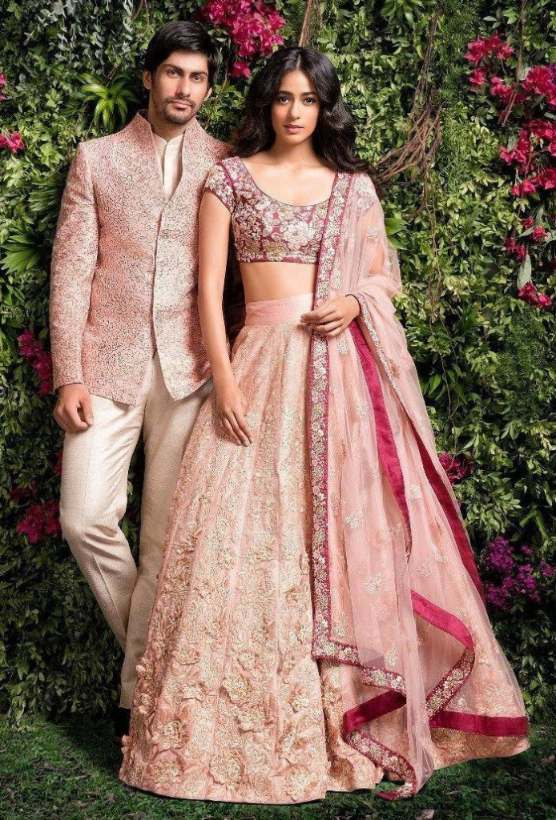Source – theunstitchd

Also read – The Perfect [Summer Wedding Outfit Ideas](https://www.bewakoof.com/blog/the-perfect-summer-wedding-outfit-ideas-what-to-wear-styling-tips/): What to Wear & Styling Tips

* **Gala Outfits**: Gala events are formal occasions that require sophisticated and elegant attire. Men can opt for a classic tuxedo, paired with a bow tie, dress shirts for men, and dress [**shoes for men**](https://bewakoof.app.link/?%243p=blog_text_clicks&~campaign=text_clicks&~channel=blog_text_clicks&~feature=collection_page&$desktop_url=https://www.bewakoof.com/men-casual-shoes?&$fallback_url=https://www.bewakoof.com/men-casual-shoes?&$deeplink_path=www.bewakoof.com/men-casual-shoes?&utm_source=blog_text_clicks&utm_medium=blog_text_click&utm_campaign=text_clicks&gclid=%7Bgclid%7D&~ad_set_id=%7Badgroupid%7D&~campaign_id=%7Bcampaignid%7D&~keyword=%7Bkeyword%7D&~placement=%7Bplacement%7D).
  + Women can opt for a formal gown that complements their body shape and skin tone. The gown can be long or short, with a fitted or flared silhouette, and can have intricate detailing such as beading or lace. It’s important to choose the right accessories, such as statement jewelry and clutch bags, to complement the outfit.

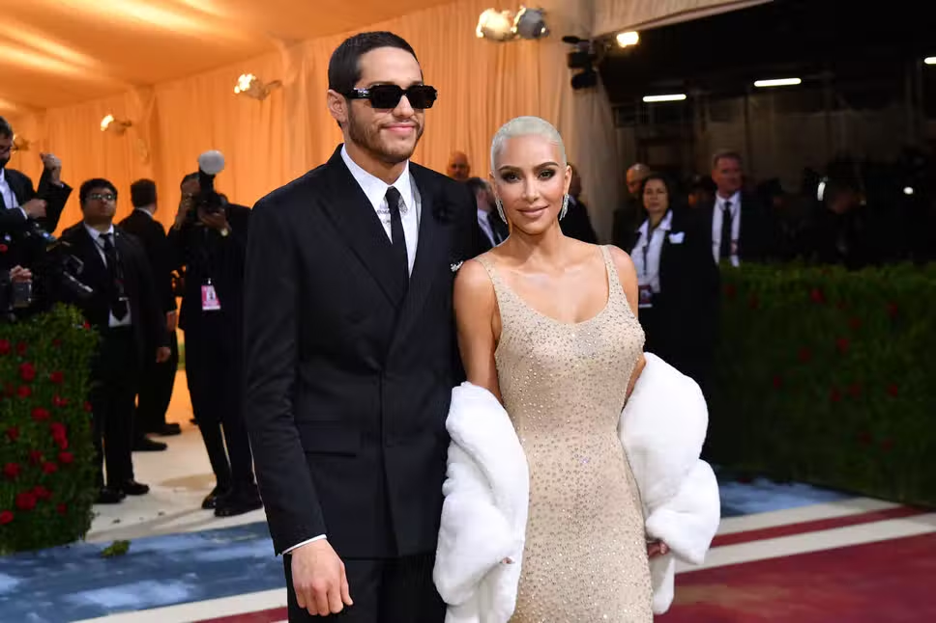Source – Evening Standard

* **Formal Event Dress Code Guidelines**: When attending a formal event, it’s essential to follow the event’s dress code guidelines to ensure you are dressed appropriately.
* If the dress code is black-tie, men should wear a tuxedo, while women should wear a formal gown.



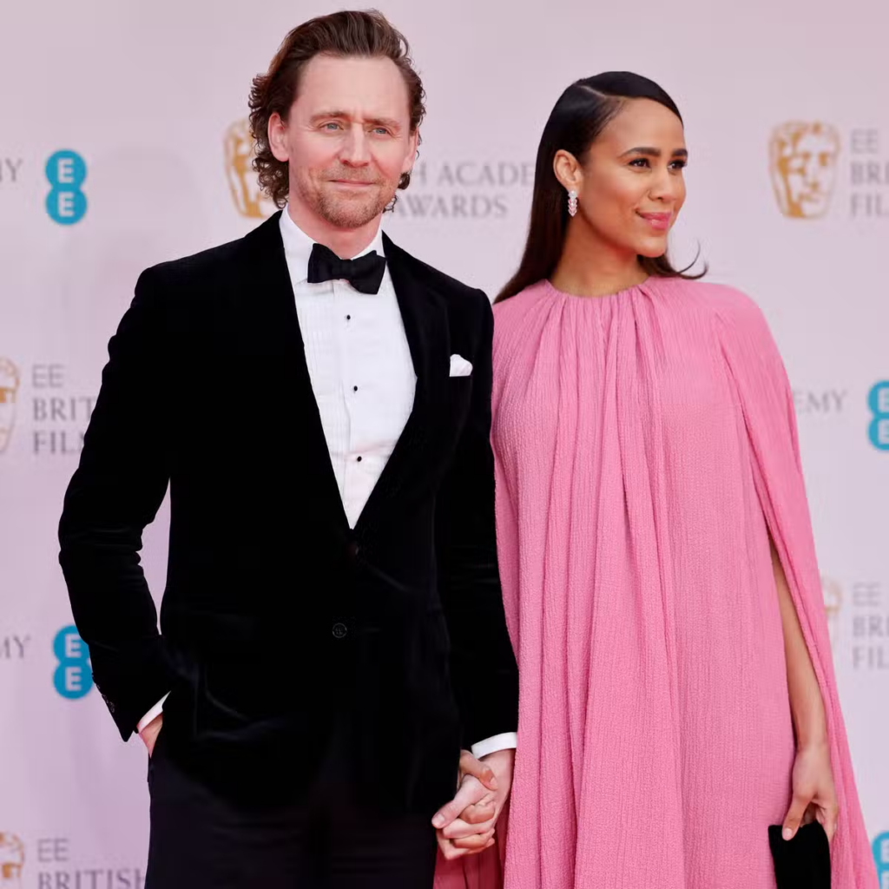Source – Evening Standard

* If the dress code is semi-formal, men can wear a suit and tie, while women can wear a cocktail dress or a dressy skirt and blouse. For daytime events, men can wear a light-colored suit, while women can opt for a floral dress or a pantsuit.

Also read: A Guide to [Men’s Formal Wear Outfits](https://www.bewakoof.com/blog/mens-formal-wear-outfits-ideas/): The Essential Guide for Choosing the Perfect Look for Every Occasion



**Be the Best-Dressed on Special Occasions like Anniversaries & Birthdays**

Occasions like anniversaries and birthdays are super special, and you don’t want to overdress or underdress. If you are not single then you have to balance it with your partner. Both of you can’t be dressed starkly opposite. Right?



In this section, we will tell you how to be best dressed in your **special occasion outfits** for these two events.

**Anniversary Outfits**

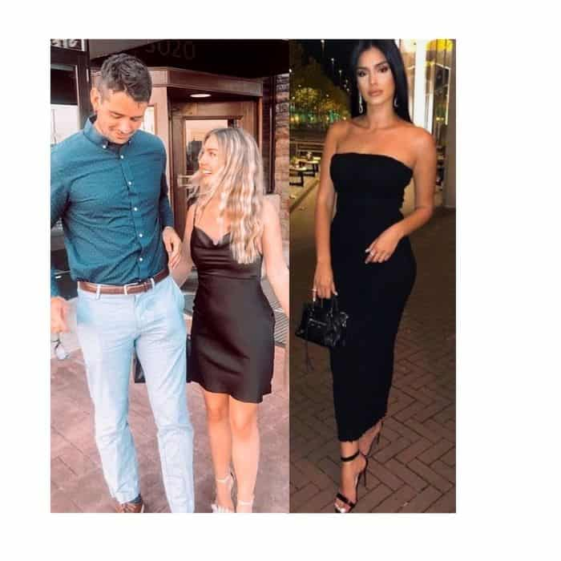Source – Roots Academy

Anniversaries need **special occasion outfits** that have an elegant and sophisticated appearance. Men can opt for a classic suit with [**shirts for men**](https://bewakoof.app.link/?%243p=blog_text_clicks&~campaign=text_clicks&~channel=blog_text_clicks&~feature=collection_page&$desktop_url=https://www.bewakoof.com/men-shirts?&$fallback_url=https://www.bewakoof.com/men-shirts?&$deeplink_path=www.bewakoof.com/men-shirts?&utm_source=blog_text_clicks&utm_medium=blog_text_click&utm_campaign=text_clicks&gclid=%7Bgclid%7D&~ad_set_id=%7Badgroupid%7D&~campaign_id=%7Bcampaignid%7D&~keyword=%7Bkeyword%7D&~placement=%7Bplacement%7D) and a tie. The suit can be in a solid color or a subtle pattern. For women, a cocktail dress or a jumpsuit is a great choice. Accessories like statement jewelry and a clutch bag can elevate the look.

**Birthday Outfits**

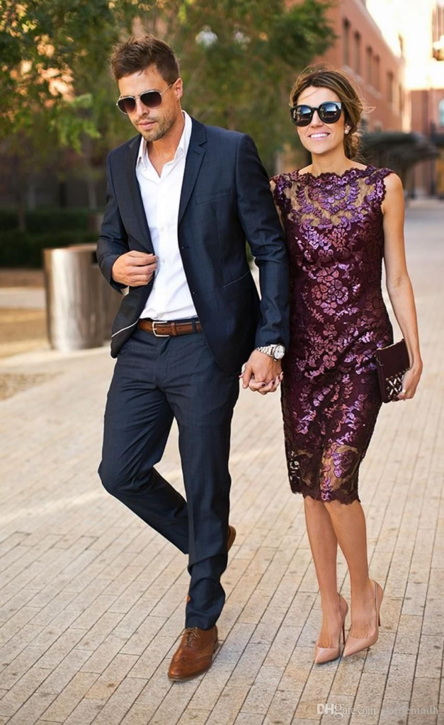Source – zydisradio

Birthdays are fun occasions that require playful and stylish outfits. Usually, a **birthday party dress code** is casual. Men can opt for a casual blazer, paired with a dress shirt and chinos. For women, a sundress or a skirt and blouse set is a great choice.



Also read: Top 10 Cutest [Birthday Outfits For Women](https://www.bewakoof.com/blog/best-birthday-outfits-for-women/) To Try

**Tips to be the Best-Dressed**

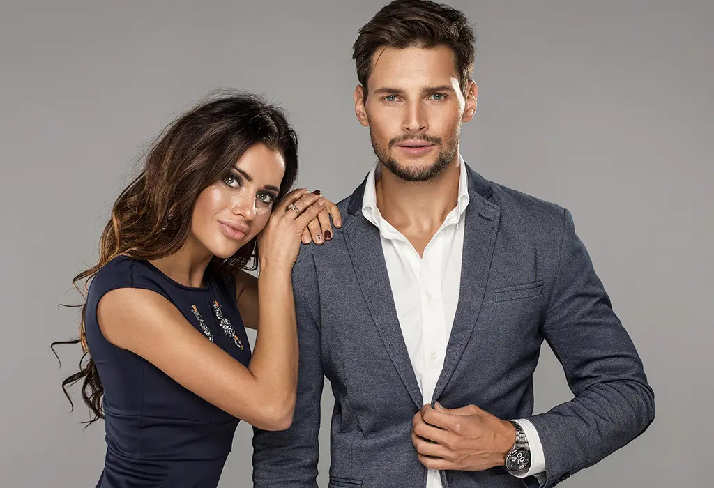Source – Real Men Real Style

* **Dress for the occasion**: Make sure you have dressed appropriately for the occasion. If there is a special occasion dress code then stick to it. If it’s a formal event, opt for elegant attire. If it’s a casual event, opt for playful and stylish attire.
* **Complement the venue**: Take cues from the venue and choose an outfit that complements the setting. For example, if it’s an outdoor event, opt for lightweight fabrics and breathable outfits.



* **Accessorize wisely**: Choose accessories that complement your special occasion outfit and add a touch of elegance or fun to your look. For example, statement jewelry can elevate a simple outfit, while colorful [**shoes for women**](https://bewakoof.app.link/?%243p=blog_text_clicks&~campaign=text_clicks&~channel=blog_text_clicks&~feature=collection_page&$desktop_url=https://www.bewakoof.com/casual-shoes-for-women?&$fallback_url=https://www.bewakoof.com/casual-shoes-for-women?&$deeplink_path=www.bewakoof.com/casual-shoes-for-women?&utm_source=blog_text_clicks&utm_medium=blog_text_click&utm_campaign=text_clicks&gclid=%7Bgclid%7D&~ad_set_id=%7Badgroupid%7D&~campaign_id=%7Bcampaignid%7D&~keyword=%7Bkeyword%7D&~placement=%7Bplacement%7D) can add a playful touch.
* **Choose the right fit**: Make sure your outfit fits you well and complements your body shape. A well-fitted outfit can make you look and feel confident and stylish.

Also read: [Tips To Dress Well In College And Office](https://www.bewakoof.com/blog/tips-to-dress-well-in-college-and-office/)



**Tips on Dressing for Fun-Filled Events like Festivals & Concerts**

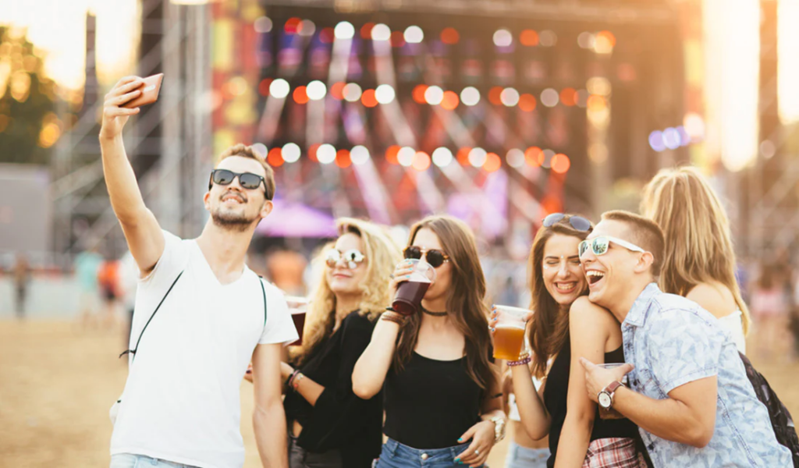Source – Tiege hanley

While dressing for fun-filled occasions like festivals and concerts, your **event attire** should be all about comfort, expression, and creativity. Follow these tips to create an outfit that reflects your style and makes you feel confident and ready to enjoy:

* **Dress for Comfort**: Comfort is key when it comes to selecting concert and festival outfits. Opt for lightweight and breathable fabrics such as cotton or linen. Flowy dresses for women, skirts, and shorts are great options. Pair them with comfortable footwear like sneakers, boots, or sandals. One of the best concert attire ideas is to avoid high heels or tight-fitting shoes that can make it difficult to move around.
* **Experiment with Colors and Patterns**: Festivals and concerts are all about fun and expression. Don’t be afraid to play with colors and patterns. The **event attire** selection should be vibrant. Go for bright colors like neon or pastels, and mix and match different patterns such as florals, stripes, or checks.



* **Layer Up**: Festivals and concerts can be unpredictable, weather-wise. Be prepared by layering up. Wear a light jacket, cardigan, or hoodie that can be easily tied around your waist or carried in a bag. Layering can also add dimension and interest to your outfit.
* **Accessorize**: Accessorizing can take your festival or concert outfit to the next level. Go for statement jewelry like bold earrings or layered necklaces. Add a touch of sparkle with glittery or metallic temporary tattoos. Wear a fun hat or a bandana to protect your face from the sun.
* **Express Yourself**: Festivals and concerts are all about expressing yourself. Don’t be afraid to wear something that truly represents you and your style. Add a personal touch to your outfit, such as a vintage band tee, a denim jacket with patches or pins, or a handmade accessory.



Also read: An Encyclopedic Guide On [What to Wear to a Concert](https://www.bewakoof.com/blog/what-to-wear-to-a-concert/)

**What are the Best Outfit Ideas for Semi-Formal Events?**

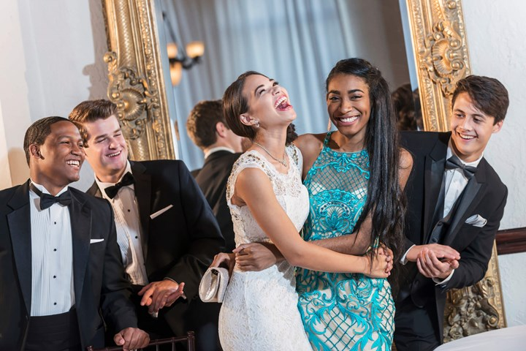Source – Who Magazine

Dressing for semi-formal events is tricky! You don’t know how much is too much. This section will give you the best semi-formal outfit ideas. Keep reading our semi-formal attire guidelines to look your best.

* **Jumpsuits**: Jumpsuits are versatile and chic, making them a great choice for semi-formal events. Look for jumpsuits in luxe fabrics like silk or satin, and opt for classic colors like black, navy, or burgundy. Pair with statement earrings and strappy heels for a sophisticated look.



* **Midi Dresses**: Midi [**dresses for women**](https://bewakoof.app.link/?%243p=blog_text_clicks&~campaign=text_clicks&~channel=blog_text_clicks&~feature=collection_page&$desktop_url=https://www.bewakoof.com/women-dresses?&$fallback_url=https://www.bewakoof.com/women-dresses?&$deeplink_path=www.bewakoof.com/women-dresses?&utm_source=blog_text_clicks&utm_medium=blog_text_click&utm_campaign=text_clicks&gclid=%7Bgclid%7D&~ad_set_id=%7Badgroupid%7D&~campaign_id=%7Bcampaignid%7D&~keyword=%7Bkeyword%7D&~placement=%7Bplacement%7D) are a popular choice for semi-formal events because they are comfortable and stylish. Look for dresses with interesting details like ruffles, asymmetrical hemlines, or statement sleeves. Accessorize with a statement clutch and sleek pumps.
* **Co-Ord Sets**: **Co-ord sets** are a trendy option for semi-formal events. Look for sets in elegant fabrics like velvet or jacquard. Coordinate the colors and patterns of the top and bottom for a cohesive look. Finish the outfit with sleek heels and minimal jewelry.
* **Blazers and Trousers**: A blazer and trousers combination is a timeless choice for semi-formal events. Choose a well-tailored blazer in a classic color like black, navy, or grey. Pair with trousers in a complementary color and finish the look with elegant heels and statement earrings.
* **Skirt and Blouse**: A skirt and blouse combination is a feminine and sophisticated option for semi-formal events. Look for a midi skirt in a luxe fabric like silk or satin, and pair it with a blouse in a complementary color or pattern. Add a statement necklace and strappy heels to complete the look.

**To sum it up…**

Styling yourself for every occasion doesn’t have to be a daunting task. Whether you’re dressing for weddings, festivals, or any other event, remember to have fun, experiment with colors and patterns, and choose outfits that make you feel comfortable and confident. Don’t be afraid to express your personality and show off your style. With our tips and tricks, you’re sure to turn heads and leave a lasting impression wherever you go. So, go ahead, let your inner fashionista shine and enjoy dressing up for every occasion!

*Image credits: The copyrights of the images used in this post belong to their respective owners. The credits where known are specified under the image - if you're the owner of an image and want it removed, please contact us.*

[concert](https://www.bewakoof.com/blog/tag/concert/)[concert outfits](https://www.bewakoof.com/blog/tag/concert-outfits/)[dressing](https://www.bewakoof.com/blog/tag/dressing/)[dressing style](https://www.bewakoof.com/blog/tag/dressing-style/)[dressing tips](https://www.bewakoof.com/blog/tag/dressing-tips/)[fashion](https://www.bewakoof.com/blog/tag/fashion/)[festival](https://www.bewakoof.com/blog/tag/festival/)[festival outfits](https://www.bewakoof.com/blog/tag/festival-outfits/)[men](https://www.bewakoof.com/blog/tag/men/)[men's fashion](https://www.bewakoof.com/blog/tag/mens-fashion/)[mens clothing](https://www.bewakoof.com/blog/tag/mens-clothing/)[occasion](https://www.bewakoof.com/blog/tag/occasion/)[wedding](https://www.bewakoof.com/blog/tag/wedding/)[wedding outfits](https://www.bewakoof.com/blog/tag/wedding-outfits/)[women](https://www.bewakoof.com/blog/tag/women/)[women fashion](https://www.bewakoof.com/blog/tag/women-fashion/)

Share.[Facebook](https://www.facebook.com/sharer.php?u=https%3A%2F%2Fwww.bewakoof.com%2Fblog%2Fdressing-for-different-occasions%2F)[Twitter](https://twitter.com/intent/tweet?url=https%3A%2F%2Fwww.bewakoof.com%2Fblog%2Fdressing-for-different-occasions%2F&text=Dressing%20for%20Different%20Occasions%3A%20How%20to%20Dress%20for%20Weddings%2C%20Festivals%2C%20and%20More)[WhatsApp](https://wa.me/?text=Dressing%20for%20Different%20Occasions%3A%20How%20to%20Dress%20for%20Weddings%2C%20Festivals%2C%20and%20More%20https%3A%2F%2Fwww.bewakoof.com%2Fblog%2Fdressing-for-different-occasions%2F)[**Save**](https://www.pinterest.com/pin/create/button/?guid=jTqRu_e9aA3J-2&url=https%3A%2F%2Fwww.bewakoof.com%2Fblog%2Fdressing-for-different-occasions%2F&media=https%3A%2F%2Fwww.bewakoof.com%2Fblog%2Fwp-content%2Fuploads%2F2023%2F04%2FDressing-for-Different-Occasions.jpg&description=Dressing%20for%20Different%20Occasions%3A%20How%20to%20Dress%20for%20Weddings%2C%20Festivals%2C%20and%20More)[LinkedIn](https://www.linkedin.com/shareArticle?mini=true&url=https%3A%2F%2Fwww.bewakoof.com%2Fblog%2Fdressing-for-different-occasions%2F)[Telegram](https://t.me/share/url?url=https%3A%2F%2Fwww.bewakoof.com%2Fblog%2Fdressing-for-different-occasions%2F&title=Dressing%20for%20Different%20Occasions%3A%20How%20to%20Dress%20for%20Weddings%2C%20Festivals%2C%20and%20More)

 Previous Article[A Guide to Building the Perfect Capsule Wardrobe for Men: Essential Tips and Ideas](https://www.bewakoof.com/blog/capsule-wardrobe-for-men/)

Next Article [The Essential Guide to Finding the Perfect Clothing Fit Every Time](https://www.bewakoof.com/blog/clothing-fit/)



[**Bewakoof**](https://www.bewakoof.com/blog/author/bewakoof/)

* [Website](https://wwww.bewakoof.com/)
* [Facebook](https://www.facebook.com/bewakoofcom)
* [X (Twitter)](https://twitter.com/bewakoof)
* [Pinterest](https://www.pinterest.com/bewakoof/)
* [Instagram](https://www.instagram.com/bewakoofofficial/)

Bewakoof.com is the leading online destination for fashion and lifestyle trends in India. From the latest fashion, beauty, and style tips to celebrity gossip, we have it all. Do not miss our latest collection in [**Casual Shoes**](https://www.bewakoof.com/casual-shoes), [**Customize T-Shirts**](https://www.bewakoof.com/custom-tshirts)

**Related Posts**

[**The Ultimate Black Denim Jacket Combination: Top Styling Tips For Any Occasion**](https://www.bewakoof.com/blog/black-denim-jacket-combination/)

[stylish](https://www.bewakoof.com/blog/stylish/)

[**The Ultimate Guide: How To Style White Hoodie Outfit For A Versatile Wardrobe**](https://www.bewakoof.com/blog/white-hoodie-outfit/)

[Fashion](https://www.bewakoof.com/blog/fashion/)

[**Tripti Dimri Outfit: Best Style Moments That Prove She’s A Rising Fashion Icon**](https://www.bewakoof.com/blog/tripti-dimri-outfit-ideas/)

[Entertainment](https://www.bewakoof.com/blog/entertainment/)

Comments are closed.

[](https://bewakoof.app.link/?%243p=blog_sidebar_cta&~campaign=blog_sidebar&~channel=blog_sidebar-cta&~feature=website_direct&$desktop_url=https://www.bewakoof.com/?&$fallback_url=https://www.bewakoof.com/?&$deeplink_path=www.bewakoof.com/?&utm_source=blog&utm_medium=blog&utm_campaign=blog_sidebar&gclid=%7Bgclid%7D&~ad_set_id=%7Badgroupid%7D&~campaign_id=%7Bcampaignid%7D&~keyword=%7Bkeyword%7D&~placement=%7Bplacement%7D)

Popular Posts

[**The Ultimate Black Denim Jacket Combination: Top Styling Tips For Any Occasion**](https://www.bewakoof.com/blog/black-denim-jacket-combination/)

December 30, 2024

[**New Year, New Beginnings: What is Your New Year’s Resolutions?**](https://www.bewakoof.com/blog/new-year-resolutions/)

December 27, 2024

[**The Ultimate Guide: How To Style White Hoodie Outfit For A Versatile Wardrobe**](https://www.bewakoof.com/blog/white-hoodie-outfit/)

December 23, 2024

[**50 Christmas Wishes, Quotes, Messages & Greeting to Your Loved Ones**](https://www.bewakoof.com/blog/christmas-wishes/)

December 19, 2024



Web Stories

[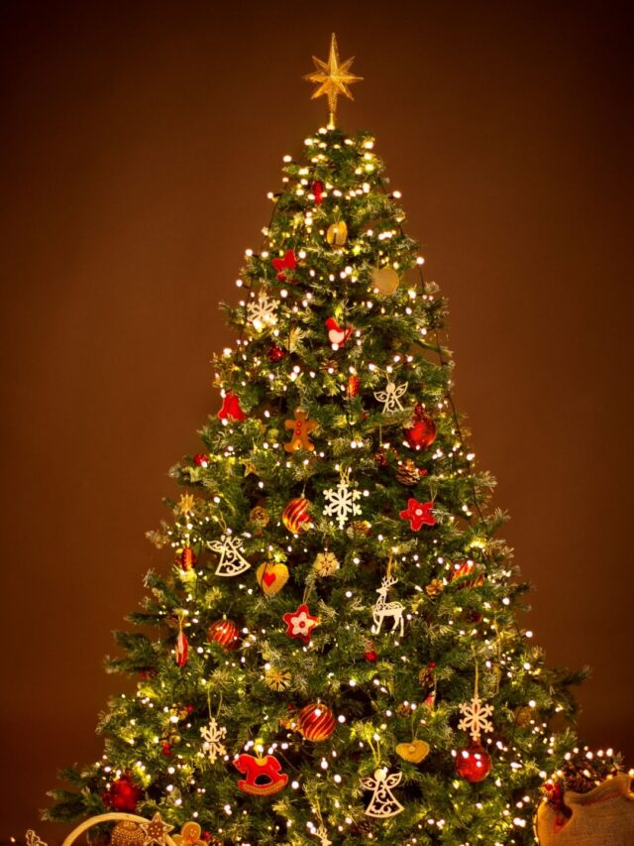](https://www.bewakoof.com/blog/web-stories/christmas-tree-decoration-ideas/)

**Tree of Wonder : Decorative Tips for a Dazzling Christmas**

[](https://www.bewakoof.com/blog/web-stories/best-christmas-destinations-in-india/)

**JINGLE All THE WAY : Best Christmas Destinations in India**

[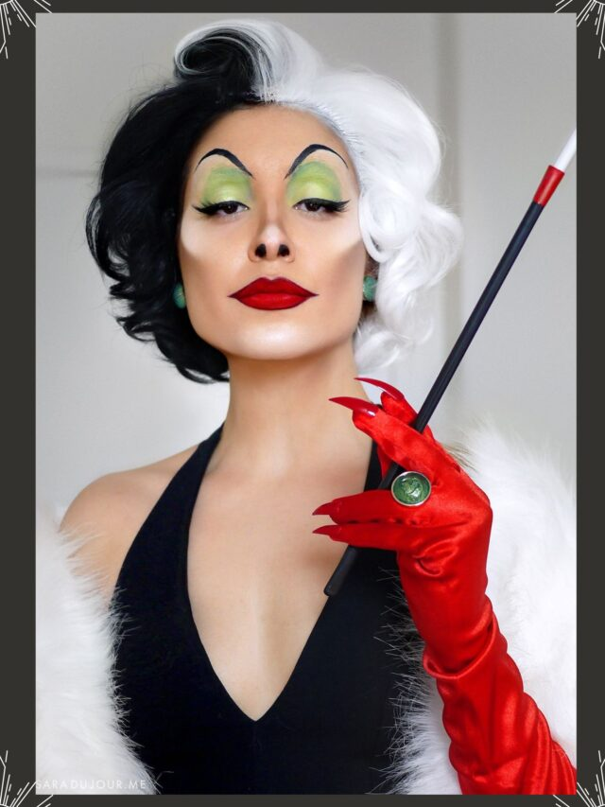](https://www.bewakoof.com/blog/web-stories/womens-halloween-costumes/)

**Frighteningly Fabulous: Women’s Halloween Costume Guide**

[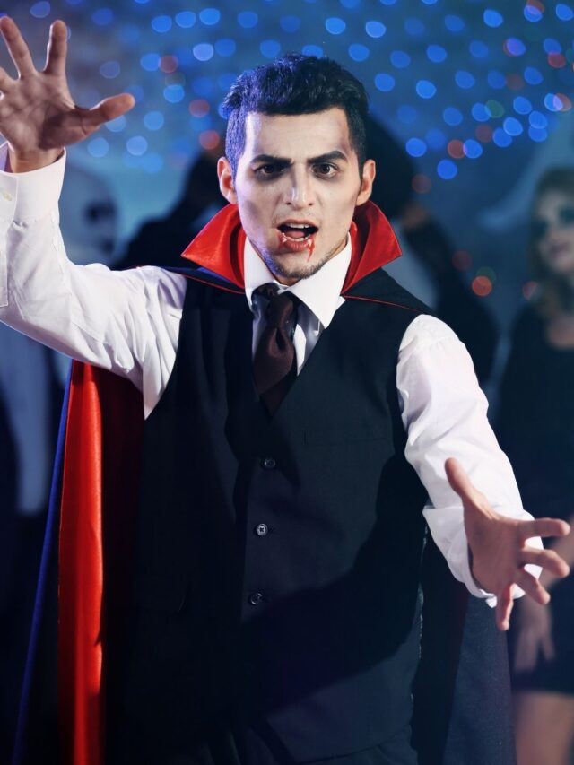](https://www.bewakoof.com/blog/web-stories/dare-to-scare-creative-halloween-costume-ideas-for-men/)

**Dare To Scare – Creative Halloween Costume Ideas For Men**

[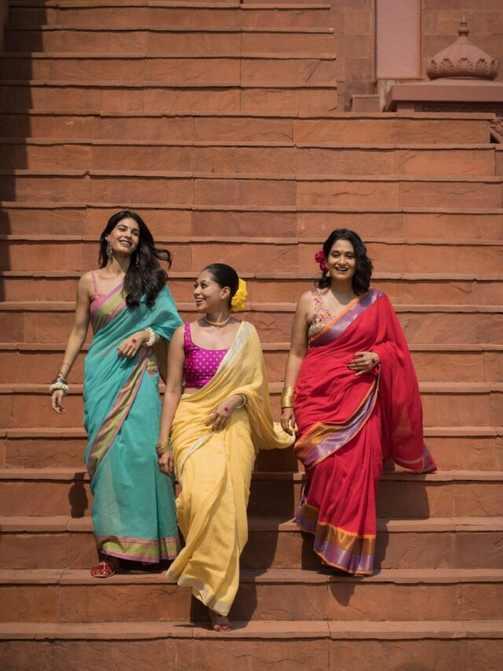](https://www.bewakoof.com/blog/web-stories/actress-inspired-diwali-outfit-ideas/)

**Festive Fashion: Actress-Inspired Diwali Outfit Ideas For Women**

Categories

Top of Form

Categories                                                 

Bottom of Form

**About**



From discovering what's in vogue, to insights on the industry, fabulous feature articles, and all the inside scoop, this is your go-to place for all things Bewakoof! Keep yourself updated with all the latest fashion trends.

[Facebook](https://www.facebook.com/bewakoofcom)[X (Twitter)](https://twitter.com/bewakoof)[Instagram](https://www.instagram.com/bewakoofofficial/)[Pinterest](https://www.pinterest.com/bewakoof/)[YouTube](https://www.youtube.com/channel/UCOdNk0jtkw06mg77pniuIuw)[LinkedIn](https://in.linkedin.com/company/bewakoof-com---bewakoof-brands-pvt-ltd-)

**Latest Posts**

[**The Ultimate Black Denim Jacket Combination: Top Styling Tips For Any Occasion**](https://www.bewakoof.com/blog/black-denim-jacket-combination/)

December 30, 2024

[**New Year, New Beginnings: What is Your New Year’s Resolutions?**](https://www.bewakoof.com/blog/new-year-resolutions/)

December 27, 2024

[**The Ultimate Guide: How To Style White Hoodie Outfit For A Versatile Wardrobe**](https://www.bewakoof.com/blog/white-hoodie-outfit/)

December 23, 2024

**Follow Us On Pinterest**

**BEWAKOOF®**Bewakoof Blogs**Follow On**

Designed by [Bewakoof](https://www.bewakoof.com/).

* [Fashion](https://www.bewakoof.com/blog/fashion/)
* [Beauty](https://www.bewakoof.com/blog/beauty/)
* [Entertainment](https://www.bewakoof.com/blog/entertainment/)
* [Leisure](https://www.bewakoof.com/blog/leisure/)
* [Fitness](https://www.bewakoof.com/blog/fitness/)
* [Shopping](https://www.bewakoof.com/blog/shopping/)
* [General](https://www.bewakoof.com/blog/general/)

